final press release
(English translation)

BEER&FOOD ATTRACTION 2025:
LEADER IN EUROPE FOR THE BEVERAGE&BAR INDUSTRY

- An edition that proves the event’s European appeal with +4% of total visits

- Europe’s most complete beer excellence offer on display: 115 craft breweries and leading mainstream references, the largest foreign beer importers, and the brewing world’s major multinationals

- Mixology a top feature with +30% more exhibition space specifically for the spirits sector and the art of mixing

- New addition announced for 2026: Mixology Attraction, an event dedicated entirely to the sector, will accompany Beer&Food Attraction next year

- Strategic role of Food to complement the beverage world with the best proposals for the casual dining and aperitif channel

www.beerandfoodattraction.it
www.bbtechexpo.com

Rimini, 18th February 2025 – With the 10th edition just concluded, Italian Exhibition Group's Beer&Food Attraction event (inaugurated by the Minister for Disabilities, Alessandra Locatelli, and the Honourable Mirco Carloni, President of the Chamber of Deputies’ Agriculture Commission), decisively affirms its position as European leader for the Beverage & Bar Industry by registering a +4% increase in total visits, a highly positive sign given the over 20% leap forward already achieved in 2024. 600 exhibitors (and 170 new companies), with 1,217 brands covering an exhibition area extended by 14% compared to 2024. And 302 accredited journalists (+38%).
The event gathered the foodservice world’s trends, starting with those of the beer supply chain and presenting innovations and the European continent’s most complete offer: from craft beers (with 115 craft breweries) to the mainstream, leading importers of foreign beers and the brewing universe’s big multinationals. The considerable development of the Mixology world deserves underlining: with +30% of exhibition space dedicated to the spirits sector, the 2026 edition will feature the already announced new Mixology Attraction, which will become an event in itself, with the aim of extending the focus to the cocktail sector on a par with that given to beers. Lastly, highlighting the success of this edition was the strategic role of food (which accounts for about 20% of the exhibition offer) as a complement to the Beverage universe, with the best proposals for the casual dining and aperitif channel, a moment of consumption which will be paid increasing attention.

EXHIBITION OFFER INTERNATIONALITY
European visitors grew by 11% with an increase of +55% from Northern European countries and with Eastern European countries accounting for 21% of the total number of foreign visitors. The top 10 countries included Germany, UK, Spain, Poland, the Czech Republic, France, Switzerland, Albania and Belgium. The presence of non-European countries was also significant, the most represented being Brazil, the United States, Mexico and Georgia.
With 130 buyers from 47 countries, mainly from Spain, Finland, Poland, the Czech Republic, Denmark and Sweden, the trade show is becoming increasingly international thanks to partnership with the Ministry of Foreign Affairs and International Cooperation and the Italian Trade Agency. Groups, from the American Brewers Association to Scottish Development International, provide examples. Exhibitors came from 15 countries with Germany and Spain leading the way. A consolidated presence of distributors, wholesalers, venues and top pub and pizzeria chains represented a unique networking opportunity for encounters between operators and buyers, generating considerable optimism in the sector. The 2025 edition of the event therefore signalled a breath of positive energy, confirming the show as a catalyst of opportunities for the beverage and catering world. The 10th edition of IEG's B2B show was accompanied by BBTech Expo on process technologies and Filling & Packaging to complete the Beverage supply chain offer.

FROM THE WORLD OF BEER TO THE GRAND OPENING TOWARDS THE MIXOLOGY SECTOR
One of the main themes of this edition was the strong focus on beers with content dedicated to trends, innovation and consumption evolution. The exhibition hosted the sector’s leading events, such as the Italian Craft Beer Conference organised by Unionbirrai, the Beer of the Year Award, the highest-ranking beer competition with a jury of 81 expert tasters from all over the world. Alongside these were Assobirra events. Of particular note at Beer&Food Attraction 2025 was the focus on the Mixology sector and new out-of-home trends, themes that are now central to a sector in constant transformation, which put the increase in the art of fine drinking (spirits, soft drinks, wines for mixing) in the spotlight. In this context, the Mixology Village, one of the great new entries for 2025, showcased the most prestigious spirits labels, together with the Sparkling&Mix area, with top exhibitors from the world of sparkling wine in mixology. Moreover, the Mixology Circus, which presented the evolutions of the best-known bartenders, continued to be one of the show’s most successful areas, highlighting the talent and creativity that characterises this discipline.

SECTOR ASSOCIATION EVENTS AND THE HORECA MEETING
For three days, Beer&Food Attraction was the reference point for every out-of-home supply chain thanks to the collaboration of the sector’s main associations and organisations. A leading role for Italgrob - Italian Federation of Ho.re.ca. Distributors, which organised the much-awaited International Horeca Meeting, a crucial event for the out-of-home sector with the sector’s leading operators. The Ho.re.ca. channel has reached a total value of 72 billion euros with over 3.4 million employees, thus playing a key role within the Italian food industry, which, according to Italgrob data, is worth 261 billion euros, of which 185 billion within the food&beverage sector. Beer&Food Attraction hosted numerous associations and institutional stakeholders, including Assobirra, Unionbirrai, Assobibe, Mineracqua, and FIPE – Italian Federation of Public Establishments, consolidating the strategic importance of the exhibition for networking and growth in the sector.

SUCCESSFUL EUROPEAN CULINARY COMPETITIONS
Numerous events to celebrate culinary talent and passion were held during Beer&Food Attraction, including the Global Chefs Challenge - European Grand Prix, organised by Worldchefs, with 55 competitors from 20 European countries, for an international performance of the best culinary skills. At the same time, the Italian Cuisine Championships, organised by the Italian Chefs’ Federation (FIC) and accredited by Worldchefs, saw 500 competitors compete in different categories, from hot kitchen cooking to restaurant patisserie and vegan cooking, to celebrate the country's talents. The show also staged unique events such as the Burger Battle Italia, which crowned the best gourmet hamburger chef, focusing on the trend of high-quality fast food.

THE INDUSTRY TRENDS THAT EMERGED AT BEER&FOOD ATTRACTION 2025
In 2024, the spirits market recorded 343 million purchases with cocktails accounting for the largest share (146 million) [Circana data]. Consumption was mainly concentrated in the aperitif segment, which grew to 46% of the total, while dinner and after-dinner drinks dropped slightly with consumers opting for cheaper solutions (“trading down”). Alcoholic aperitifs and gin dominated the spirits segment (55%), followed by digestive spirits (10.2%), vodka (8.7%), rum (4.8%) and whisky (2.6%). In the beer sector, according to Assobirra, business exceeded 2.5 billion euros in 2024 with about 109,000 workers involved and a total value of more than 10 billion euros. However, economic difficulties related to costs, excise duties and inflation could accentuate the downturn already recorded in 2023 when beer production in Italy was 17.4 million hectolitres. Despite rising prices, positive signs are emerging from craft beer with a trend that could establish itself in 2025 towards beers with less alcoholic content.

THE 2026 EDITION OF THE SHOW
The Mixology sector’s growing importance for the trade show is a direct response to the evolution of the out-of-home market, which in recent years has seen a surge of interest in the art of fine drinking. Hence the decision to stage an entire event dedicated to this segment next year: Mixology Attraction.
The 2026 appointment with Beer&Food Attraction will be from 15th to 17th February, together with the new Mixology Attraction.

ABOUT BEER&FOOD ATTRACTION 2025
Dates: 16 – 18 February 2025; Organization: Italian Exhibition Group SpA; edition: 10th; frequency: annual; info: https://www.beerandfoodattraction.it/

ABOUT BBTECH EXPO 2025
Dates: 16 – 18 February 2025; Organization: Italian Exhibition Group SpA; edition: 7th; frequency: annual; info: https://www.bbtechexpo.com/

PRESS CONTACT ITALIAN EXHIBITION GROUP
Head of media relation & corporate communication: Elisabetta Vitali; press office manager: Marco Forcellini, Pierfrancesco Bellini; press office coordinator: Luca Paganin; press office specialist: Mirko Malgieri;
international press office coordinator: Silvia Giorgi; media@iegexpo.it

MEDIA AGENCY MEDIA AGENCY BEER&FOOD ATTRACTION-BBTECH EXPO: Mind The Pop - Martina Vacca: martina@mindthepop.it, mob. +39 339 748 5994; Fabrizio Raimondi: fabrizio@mindthepop.it, mob. +39 335 389 848; Stefano Chiossi: stefano@mindthepop.it, mob. + 39 388 739 4358.

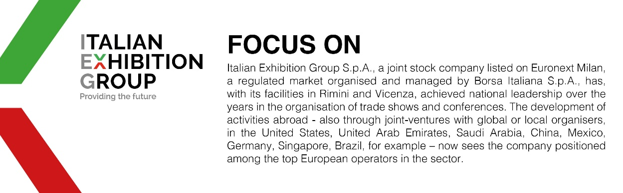

This press release contains forecast elements and estimates that reflect the management’s current opinions (“forward-looking statements”), particularly regarding future management performance, realization of investments, cash flow trends and the evolution of the financial structure. For their very nature, forward-looking statements have a component of risk and uncertainty, as they depend on the occurrence of future events. The effective results may differ (even significantly) from those announced, due to numerous factors, including, only by way of example: food service market and tourist flow trends in Italy, gold and jewellery market trends, green economy market trends; the evolution of raw material prices; general macroeconomic conditions; geopolitical factors and evolutions in the legislative framework. Moreover, the information contained in this release does not claim to be complete, and has not been verified by independent third parties. Forecasts, estimates and objectives contained herein are based on the information available to the Company as at the date of this release.

